**Unit12: Refraction of light**

**12.1 Phenomena of refraction of light**

12.1.1 Demonstrations of refraction of light

When you dip a plastic ruler into a transparent container of clean water,

the ruler appears to be bent at the point where it enters into water. This is because light rays change direction (bend) when traveling from air to water. Therefore, a ruler appears bend due to refraction of light.

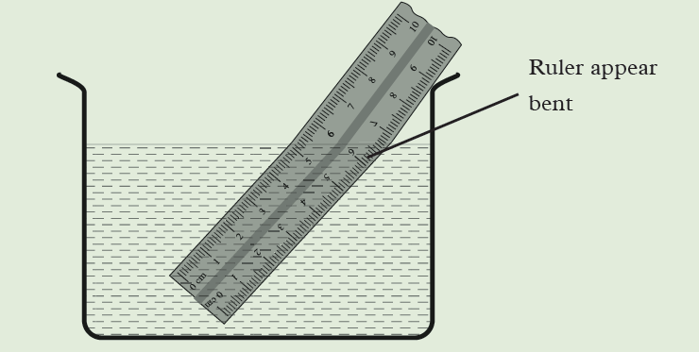

**To demonstrate how light rays travels using a rectangular glass block**

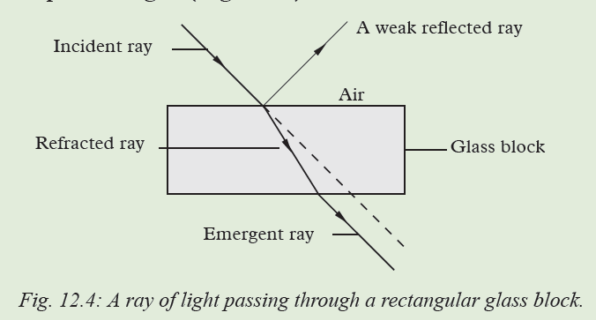

**Definition of Refraction**

**Refraction of light** *is the bending of light rays when they travel from one medium to another of different optical density*. Also, refraction is the change of direction when light rays travel from one medium to another.

Experiments show that the velocity of light in air (vacuum) is 3 × 108 m/s. The velocity of light is less in all the other media. Hence air is considered as an optically ***rarer medium*.** All the other media, are considered as **optically *denser media*** *than air*.

**12.1.2 Terms associated with refraction of light**

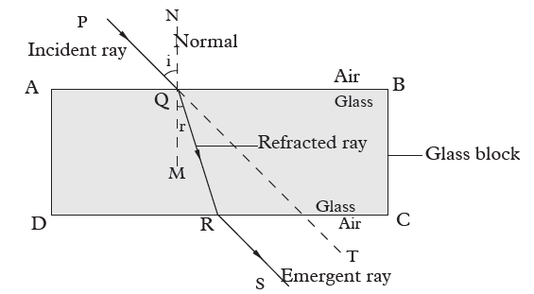

When light is moving from an optically dense medium to an optically less dense medium, it will be refracted away from the normal.

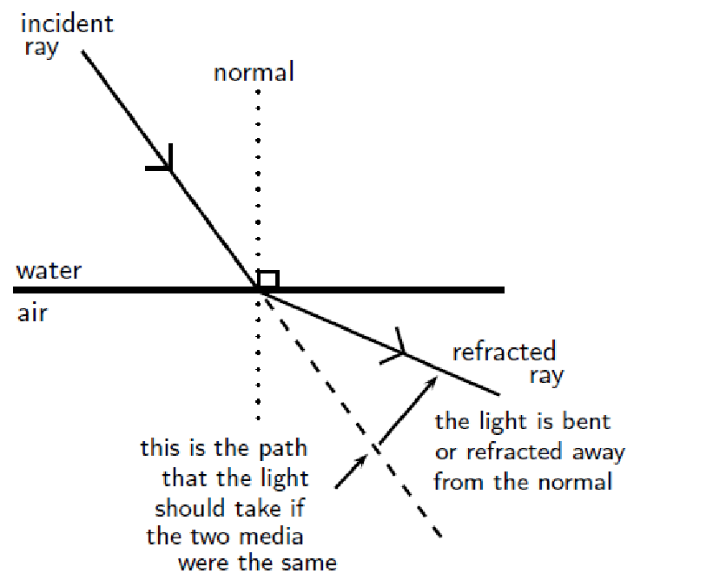

When light is moving from an optically less dense medium to an optically denser medium,it will be refracted towards the normal.

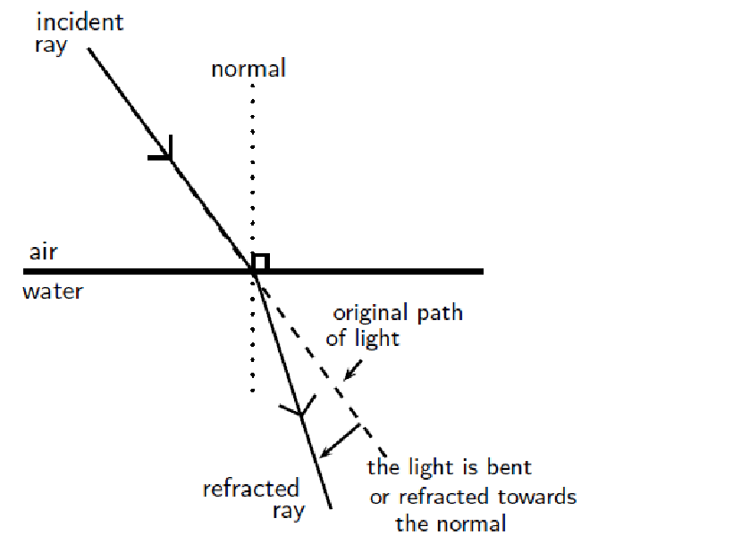

When an incident light is perpendicular to the surface, it continues to travel undeviated in a straight line but the speed of light is reduced in the glass. This is, sometimes, referred to as the *normal refraction.*

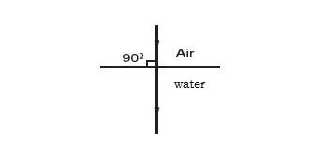

**12.1.3. Snell’s Law of refraction**

**1. The incident ray, the refracted ray and the normal, at the point of incidence, all lie in the same plane.**

**2. The ratio of the sine of the angle of incidence to the sine of the angle of refraction is a constant for a given pair of media (Snell’s law) i.e**

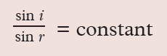

The angles of incidence and refraction when light travels from one medium to another can be calculated using Snell’s Law.

***n*1 sinθ1 = *n*2 sinθ2**

where

n1 = Refractive index of material1

n2 = Refractive index of material2 θ1 = Angle of incidence

θ2 = Angle of refraction

**12.1.4. Refractive Index**

**The refractive index (η**) is the measure of bending of light i.e is the ratio of sine of angle of incident to the sine of angle of refraction (hence Snell’s law).

The refractive index (symbol n) of a material is the ratio of the speed of light in a vacuum to its speed in the material and gives an indication of how difficult it is for light to get through the material.

A vacuum is a region with no matter in it, not even air. However, the speed of light in air is very close to that in a vacuum.

Where **n**= refractive index (no unit) **c=**speed of light in a vacuum =3x108m/s. **v=**speed of light in a given medium (m/s)

**Example 1**

A light ray, with an angle of incidence of 350, passes from water to air. Find the angle of refraction using Snell’s Law. Discuss the meaning of your answer.(refractive index of water is 1.33 , for air it is 1).

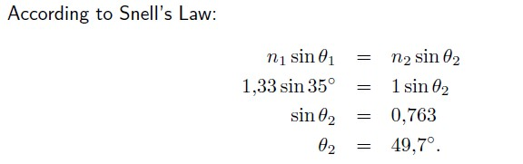**Solution**

The light ray passes from a medium of high refractive index to one of low refractive index. Therefore, the light ray is bent away from the normal.

**Example 2**

A light ray passes from water to diamond with an angle of incidence of 750. Calculate the angle of refraction.(refractive index of diamond is 2.42)

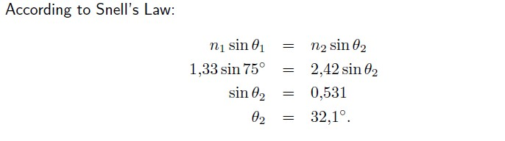

**Example 3**

Calculate the refractive index of water, given that the velocity of light in air is 3 × 108 m/s and velocity of light in water is 2.25 × 108 m/s.

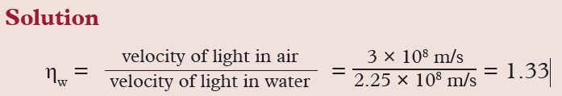

**Example 4**

The velocity of light in glass is 2.0 × 108 m/s. Calculate (a) the refractive index of glass and (b) the angle of refraction in the glass for a ray of light passing from air to glass at an angle of incidence of 40°.

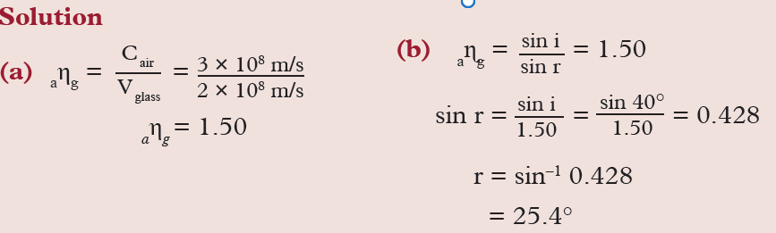

**12.1.5 The principle of reversibility of light**

Just like light rays travel from medium 1 to a medium 2, it also travels in the reverse direction i.e. travel from the medium 2 to medium 1. This is known as ***the principle of reversibility of light****.* It states that light will follow exactly the same path if its direction of travel is reversed.

It states that **light will follow exactly the same path if its direction of travel is reversed**

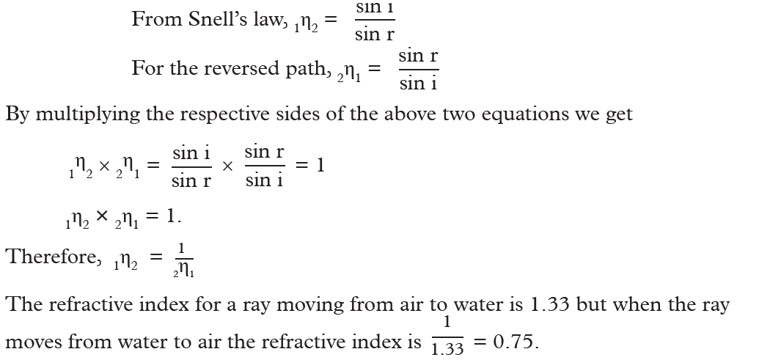

**12.1.6. Real and apparent depth**

If object and observer are situated in different medium then due to refraction, object appears to be displaced from it’s real position.

Example: An object is in denser medium and observer is in rarer medium

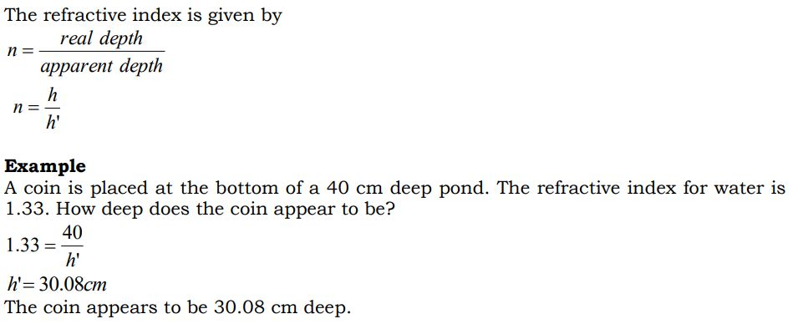

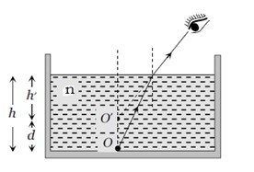

**Example 2**

The real depth of a pool of water is 6 m and the refractive index of water is 1.33. Calculate the apparent depth of the pool of water.

**Solution**

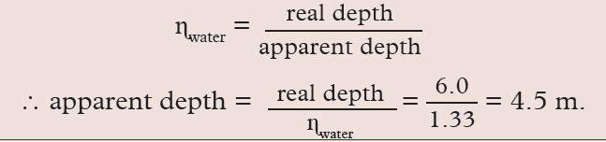

**12.1.7. Critical angle and total internal reflection**

**Critical Angle**

The critical angle is the angle of incidence where the angle of refraction is 900. The light must shine from a dense to a less dense medium.

**Total Internal Reflection**

Total internal reflection takes place when light is reflected back into the medium because the angle of incidence is greater than the critical angle.

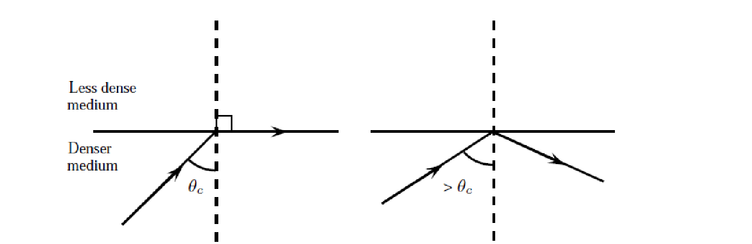

θ*c* =critical angle

**Condition:** Total internal reflection takes place when

* **light travel from an optically denser medium to an optically less dense medium.**
* **the angle of incidence in denser medium is greater than the critical angle.**

Refractive index using critical angle

Using Snell’s law, the refractive index of glass-air boundary

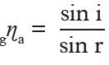

But if *i* = c, *r* = 90˚ and principle of reversibility

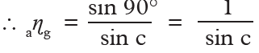

Hence, *refractive index of a medium*

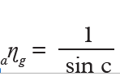

**Example1**

**Solution**

Calculate the refractive index of diamond, if the critical angle for the diamond is 24°.

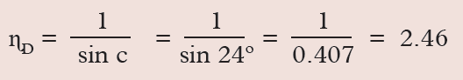

**Example2**

Calculate the critical angle for glass-air interface, if the refractive index of glass is

1.50

* 1. **Refraction of light through a prism**

1.**Deviation of a ray of light by a glass prism**

A prism has a refracting medium bound by two plane surfaces inclined to each other at an angle.

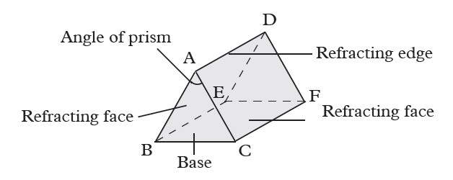

The two planes are the ***refracting faces****(ADEB and ADFC in Fig.)*

***Angle of the prism*** *(*∠*CAB):* the angle between the faces

***Refracting edge:*** The line along which the two faces meet

***Base of the prism:*** The face opposite to the angle of the prism

***Principal section of prism:*** The section of the prism cut by a plane perpendicular to the edge of the prism

In a prism, a ray of light suffers two refractions and the result is deviation

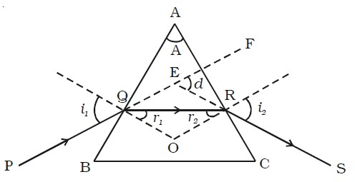

Let *i*1=angle of incidence on face AB *r*1=angle of refraction on face AB *i*2=angle of emergence on face AC

*r*2=angle of refraction on face AC *d=* angle of deviation

It can be proved that

***d* =(*i*1 +*i*2)- *A***

**1.Dispersion of light by a prism**

**A *monochromatic light***is one that has a *single colour* and a *single frequency* . White light is not monochromatic because it is made up of seven different colours. Non-monochromatic light is also called ***composite light*.**

**Dispersion** is the splitting of white light into its constituent colours. This band of colours of light is called its **spectrum**.

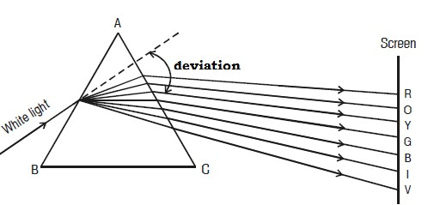

Different colours are deviated to different angles. The colours are ***red, orange, yellow, green, blue, indigo and viole****t* (**ROYGBIV**). These colours gradually blend into one another.

The above experiment was first carried out by Sir Isaac Newton. He noticed that ***violet light*** *is the most deviated colour* while ***red light*** *is the least deviated colour*

**3**.**Total internal reflection by prism**

A right angled isosceles prism is used in periscopes or binoculars. It is used to deviate light rays through 900 and also to erect the image.

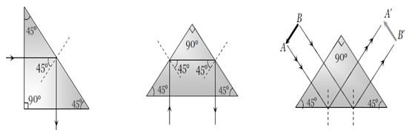

**Application of total internal reflection of light**

**(a) Prism periscope**

A periscope is a device which enables us to see over the top of an obstacle. Two right angled isosceles prism are used in *prism periscope* instead of the two plane mirrors used in a *simple periscope*. This periscope produces brighter images than those formed by plane mirrors.

A parallel beam of light normally incident on the first prism is turned through 90º and proceeds to the second prism and is again turned through 90º to reach the eye of a person. The final image produced is virtual and upright.

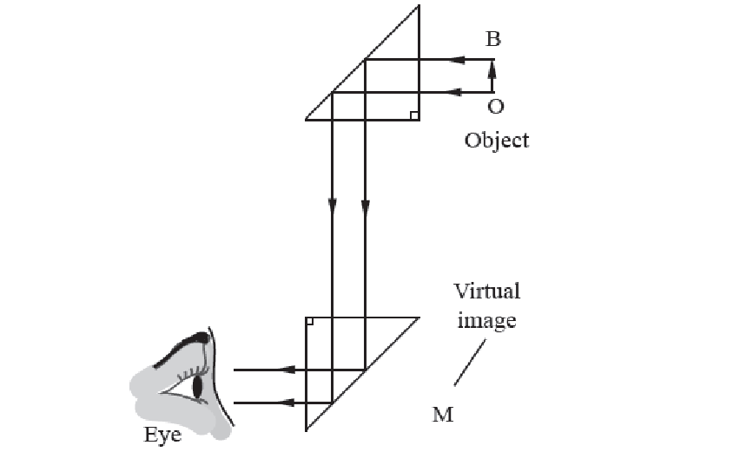

The periscope of this type is normally used in submarines to sight enemy ships over the surface of the sea.

1. **Optical fibre**

An optical fibre is a thin, transparent fibre, usually made of glass or plastic, for transmitting light. Optical fibres are usually thinner than a human hair. The construction of a single optical fibre is shown in Figure below.

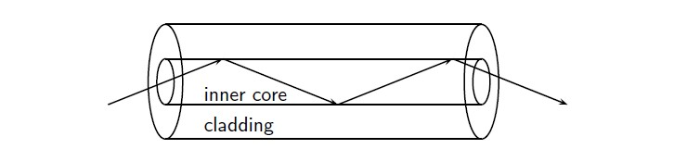

The difference in refractive index of the cladding and the core allows total internal reflection. Thus the refractive index of the inner core is greater than of the cladding.

Optical fibres are most common used in telecommunications, because information can be transported over long distances, with minimal loss of data.

In medicine, bundles of very fine flexible fibers are used to view the internal parts of a human body using an instrument called the *endoscope*.

1. **Rainbow**

A rainbow is a spectrum formed when sunlight is dispersed by water droplets in the atmosphere. Sunlight that falls on a water droplet is refracted. Because of dispersion, each color is refracted at a slightly different angle. At the back surface of the droplet, some of the light undergoes internal reflection. On the way out of the droplet, the light once again is refracted and dispersed.

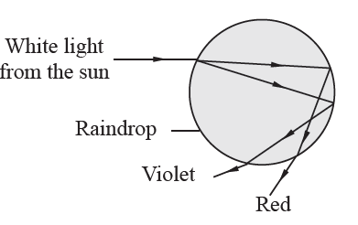

**(d) Mirage**

The mirage is an *optical illusion* that takes place in a hot desert or a hot road due to total internal reflection. A traveller sees in the distance a *shimmering pool of water* in which the surrounding objects, like a tree, appear inverted (Fig.below).

Light travelling from a denser medium (warm air) towards the earth, enters regions of rarer medium (very hot air of low density in contact with the earth) and undergoes total internal reflection at a certain point when the angle of incidence is greater than the critical angle. An observer on a distance sees the inverted image of the tree. Further, as hot air in contact with the earth rises up due to convection currents, the image appears shimmering.

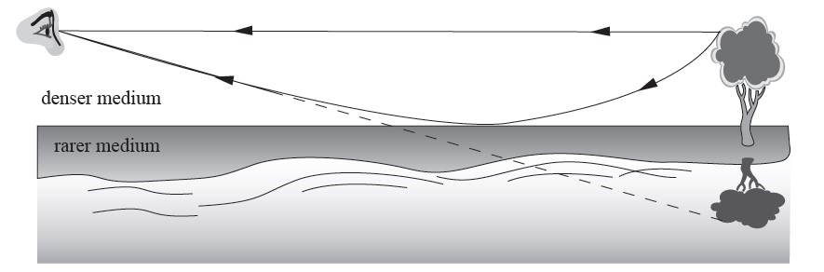

**12.3 Refraction through thin lenses**

A **thin lens** is transparent medium usually made in glass or plastic bounded by one or two spherical surfaces.

**1. Types and characteristics of lenses**

Lenses are of two basic types, **convex** which are thicker than the edges and **concave** which the reverse is true.

1. **Convex (Converging ) lens**

**Convex** lens or **converging lens** is one which is thicker at the middle than at the center.

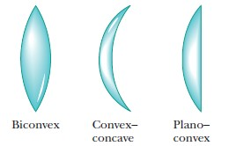

1. **Concave (Diverging) lens**

The **concave lens** or **diverging lens** is one which is thicker at the edges than at the middle

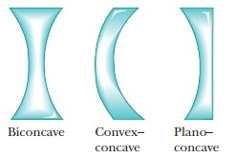

**2. Geometric terms of spherical thin lenses**

1. **Principle axis of spherical thin lenses**

The **principle axis of a spherical axis** of a spherical lens is the line joining the centre of curvature, c, of the two surfaces. We now consider paraxial rays, i.e. rays close to the principle axis making very small angles with it.

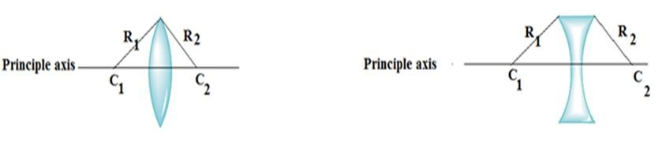

1. **Principle focus, F (or focal point) of a thin lens**

Principle focus, F (or focal point) of a thin lens is the point on the principle axis toward which paraxial rays converge (convex lens) or appear to diverge from (concave lens) after refraction.

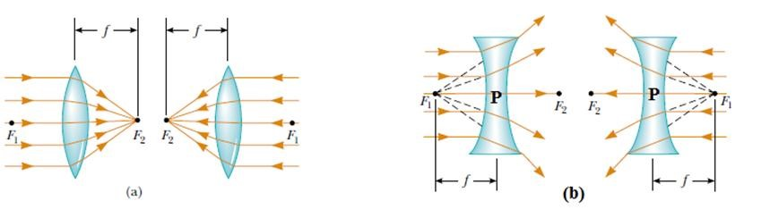

The distance **F1P** or **PF2** is calledthe focal length, f, of the lens.

A convex lens is a converging lens and has real foci while a concave lens is a diverging lens and has virtual foci.

**(c) The focal plane**

When a set of parallel rays are incident on a convex lens at an angle to the principal axis, as shown in Fig. below, the refracted rays converge to a point, on a line passing through F and perpendicular to the principal axis. The plane passing through F is the *focal plane*.

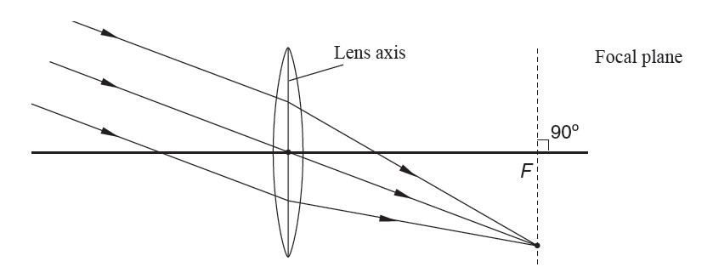

1. **Rules of Ray diagram** 
   1. A ray parallel to the principle axis after refraction passes through the principle focus or appears to diverge from it.

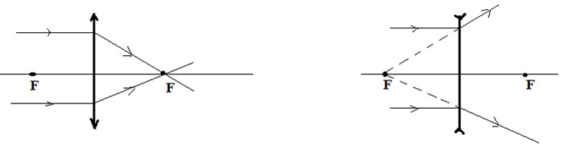

* 1. A ray through the centre of the lens (called the optical centre) continues straight undeviated (It is only slightly displaced laterally the middle of the lens acts like a thin parallel side block).

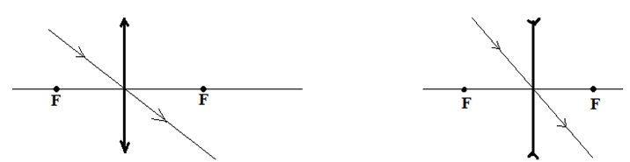

* 1. A ray through the principle focus is refracted parallel to the principal axis.

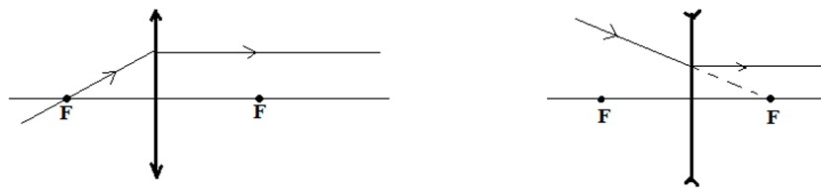

1. **Formation of images** 
   1. **Formation of images by a converging lens**

**Case 1**:Object OB just beyond C (2F)

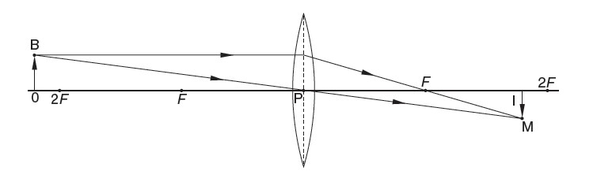

**Characteristics of image:** it isreal, inverted, and smaller than object.

**Case 2**: Object OB at 2F

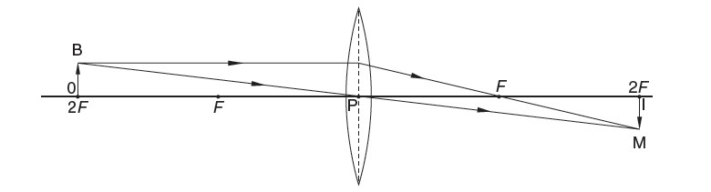

The image is: at 2 F, real, inverted and the same size as object.

C**ase 3** :Object OB between 2F and F

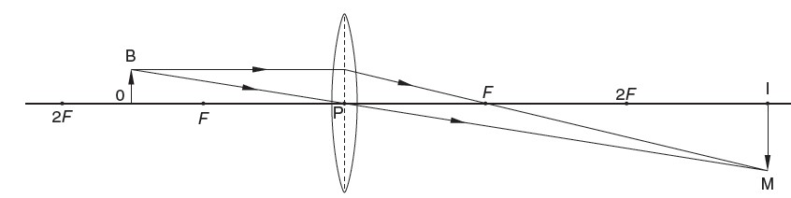

The image is: beyond 2F, real, inverted and larger than the object.

**Case 4**: Object OB at F

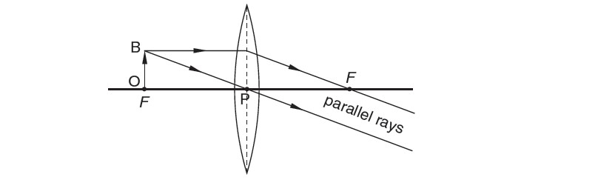

The image is: *real, inverted, magnified* image is formed far away from the lens i.e. at infinity.(cannot be described)

**Case 5:** Object OB between F and P

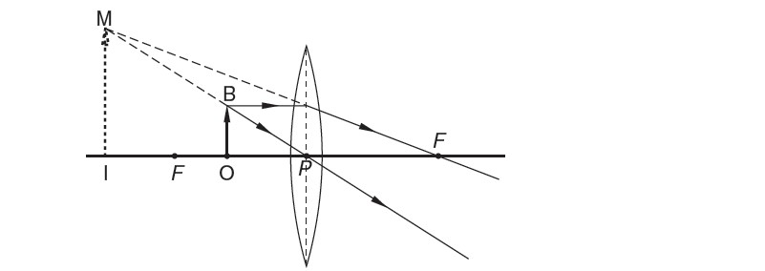

The image is: behind the object, virtual, erect and larger than object

**Case 6:** Object far away from the lens (at infinity)

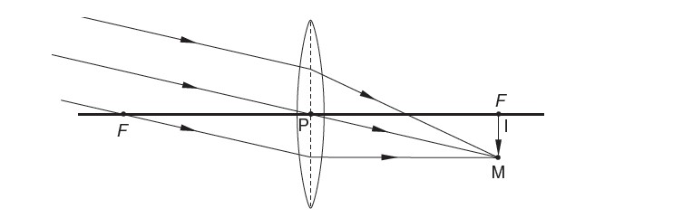

The image is: *diminished, real, inverted* image is formed at *F*.

**ii. Formation of images by a diverging lens**

**Object in front off diverging lens**

For all positions of object, the image is virtual, erect and smaller than the object, and is situated between the object and lens.

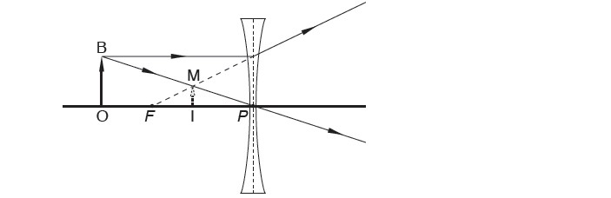

**5. Lens formula**

Consider a convex lens of focal length, *f*, which forms a real image IM of an object OB as shown in Fig. below

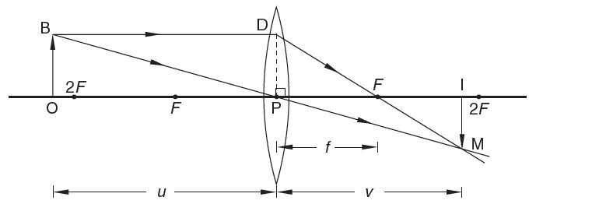

Triangles OBP and IMP are similar

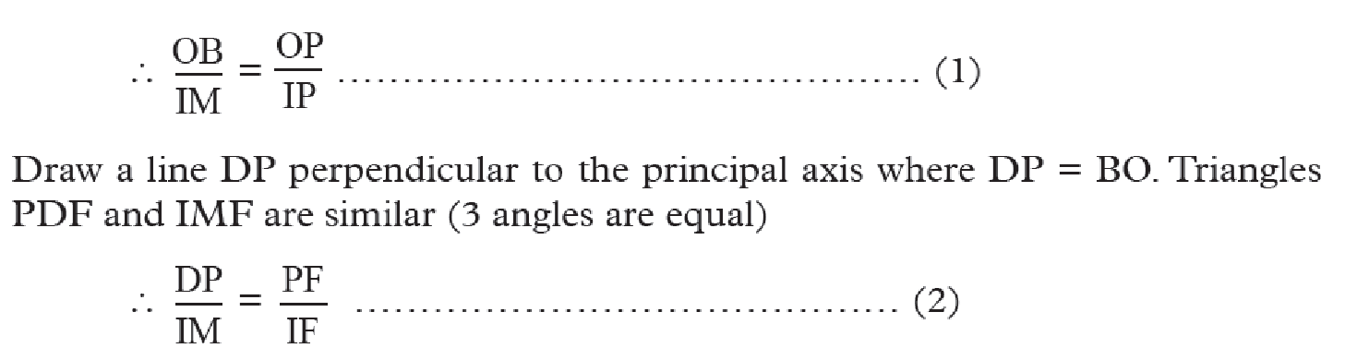

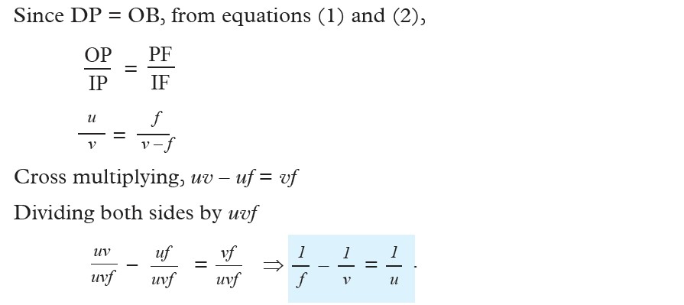

**Magnification of the lens**

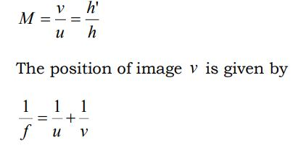

Where *u* =object distance *v*=image distance *f* =focal length *h* =height of the object *h*' = height of the object

**Note**: In calculation, the focal length of a diverging lens is taken as **negative**; the **image distance** *v* is also negative since the image is virtual.

**Example**

1. An object is placed i) 14cm, ii) 8cm in front of a convex lens of focal length10cm. Find the image distance and magnification in each case.

**Solution**

* 1. We have: 𝑢 = +14𝑐𝑚 (real object), 𝑓 = +10𝑐𝑚( convex lens)

Substitute in 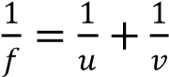 or 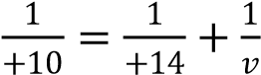

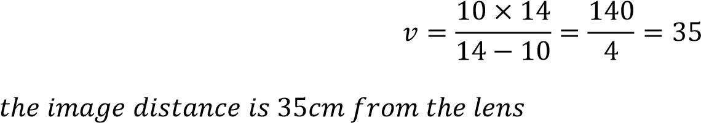

The magnification: 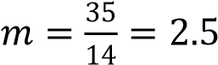

* 1. We have 𝑑 = 8𝑐𝑚 (real object),𝑓 = +10 (convex lens)

Substitute in, 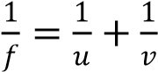

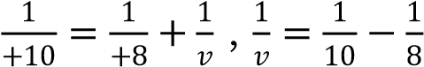

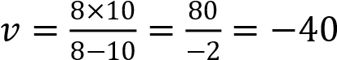 ,

𝑣 = −40𝑐𝑚  **,**

The minus sign means the image is virtual.

Also the magnification 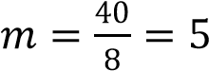

1. An object of height 2 cm is placed 8 cm from a convex lens and a virtual image is formed on the same side as the object at 24 cm from the lens. Calculate (a) the focal length of the lens (b) the height of the image formed.
2. A convex lens produces a real image of an object and the image is 3 times the size of the object. The distance between the object and the image is 80 cm. Calculate the focal length of the lens.

**6. The power of lenses**

Whenever a ray of light passes through a lens it bends except when it passes through the optical centre. The degree of **convergence** or **divergence** of a lens is expressed as **powe**r.

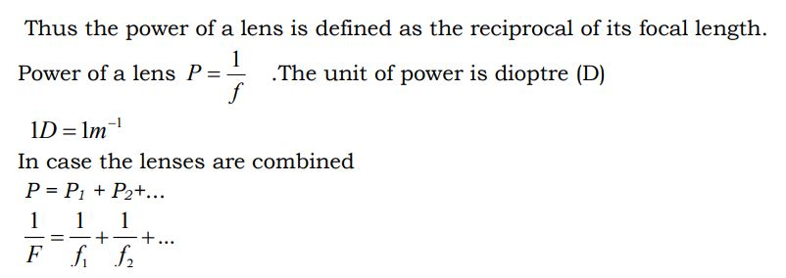A lens of short focal length deviates the rays more while a lens of large focal length

deviates the rays less. i.e. The shorter the focal length of a lens the more it converges(convex lens) or diverges(concave lens) the light.

**Example:** A lens has a focal length of 25 cm. Find the power of the lens.

**Solution**

f = 25 cm = 0.25 m. The focal length of convex lens = +ve (It forms real image)  Power = 1 /+0.25 = +4 m–1

NB: For a concave lens f = -ve (because a concave lens forms a virtual image)  Power = 1/ -0.25 = -4 m-1

**Defects of lenses**

In the derivations of lens formulae, we consider rays that are close to and parallel to the principal axis of the lens (paraxial rays). The assumption made is that the lens has a small aperture and that object points are on or close to the principal axis.

However, when we consider extended objects, the rays are non-paraxial. In this case the image and its object appears different from its object in colour, shape or sharpness of definition. This phenomenon is called image defects or aberrations. There are two important aberrations in lens namely; **spherical aberration and chromatic aberration**.

**Paraxial rays** – rays parallel to and close to the principal axis

**Non-paraxial rays** – rays parallel to but far from the principle axis.

**(a) Spherical aberration**

Spherical aberration is associated with lenses with a large aperture. As a result the image of an object point is not a point. The focal length of non-paraxial rays is less than for paraxial rays which is a characteristic of spherical surfaces.

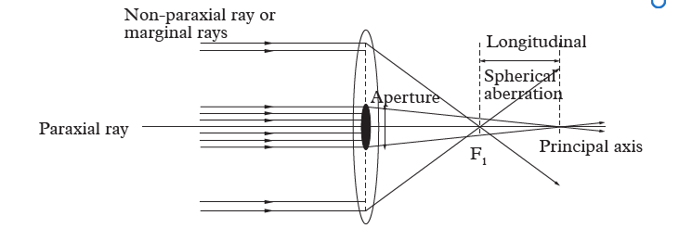

The image formed is a circular blurred and not a point. The distance F1 is the longitudinal spherical aberration for a particular object distance.

**Correction**

**1.** The effect can be corrected for a given object distance by grinding the lens surface to make them spherical.

**2.** The effect can be reduced by cutting off the marginal rays and placing a stopper in front of a lens. This is called stopping down the lens aperture. This has the disadvantage of making the image lens bright.

1. **Chromatic aberration**

If a white object is viewed through a converging lens, its image is blurred with coloured edges. This is because as seen above, a lens has a greater focal length for violet light than for red light. This is the case since ηviolet>ηred. The effects resulting

from dispersion in which there is failure of lens to focus all colours to the same convergence point is called chromatic aberration

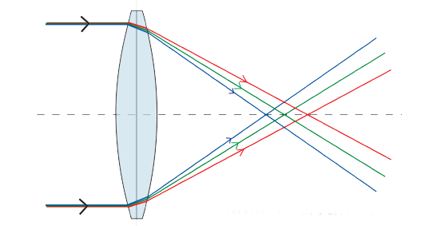

**Correction**

This defect of a lens can be eliminated by a combination of two lens cemented together. This combination is called a chromatic doublet. A chromatic doublet consists of a converging lens of crown glass combined with a diverging lens of flint glass.

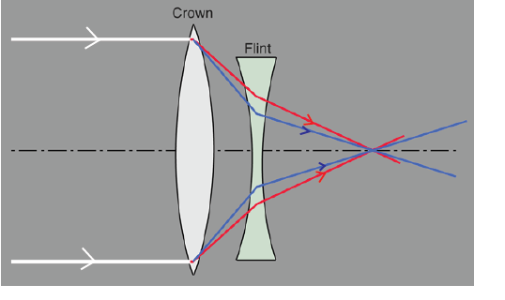

One surface of each lens has the same radius of curvature to allow them to be cemented together using Canada balsam which reduces the loss of light by reflection.

The flint glass of diverging lens produces the same refraction as the crown glass of the converging lens but in opposite direction. The end result is a converging effect.